Project: Measurement I-V characteristic of power LED.

In this project, I need to test I-V curve some of discrete electronic device. I choice LED 1W and 3W to test.
With USB-6211, I must program both acquire 2 channel and generate voltage output on the same time.

- Diagram of systems:
Drawn:

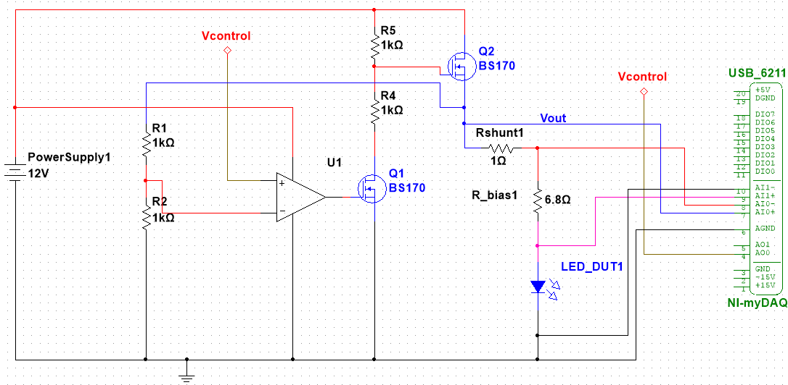
Description:
Power supply: Switching mode power supply. DC output 12V-3A supply to circuits and LED( Device Under Test- DUT).
LED:
This is some maximum spec of its.
Voltage operation:
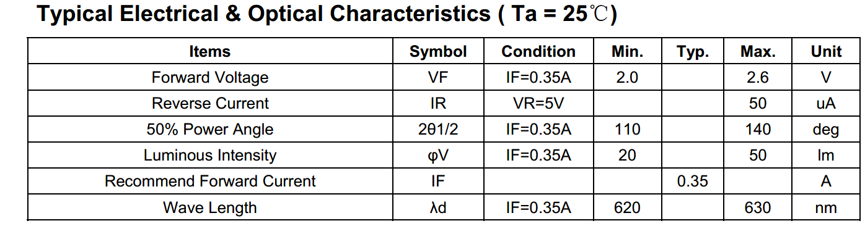
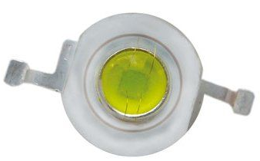
Because current operation is 350mA, it exceeds limit current output of USB-6211. So I need to build a external circuit to boost current. This voltage is controlled by voltage output by DAQ-6211.

Current maximum of USB-6211 is 2.4mA( see more on ni.com). It can't directly drive LED. So, the best solution is using Voltage control Voltage circuits.

Voltage control Voltage circuit:
This circuit allows a smaller control voltage to linearly control a larger output voltage Vo.
The resistor R1 and R2 scale the feedback to an appropriate range for the opamp.
R2/(R1+R2) = Vcontrol / Vout.

Vout: Voltage at pin S of N-MOSFET, is supplied to DUT.
Vcontrol: Volts is generated by USB DAQ.

USB DAQ:
It is used as generator and recording voltage, programming base on LabVIEW.
AI0 acquires current by Rshunt, voltage drop on shunt resistor. And the, we can get current by divided Rshunt.
Voltage/ Rshunt = Current.
AI1 acquire dropped voltage on DUT.
Because, Vcontrol will change from 0-5 can damage DUT, so I added R-bias to prevent this accident.
- Programming:
The program is built by LabVIEW.
Flow chart:

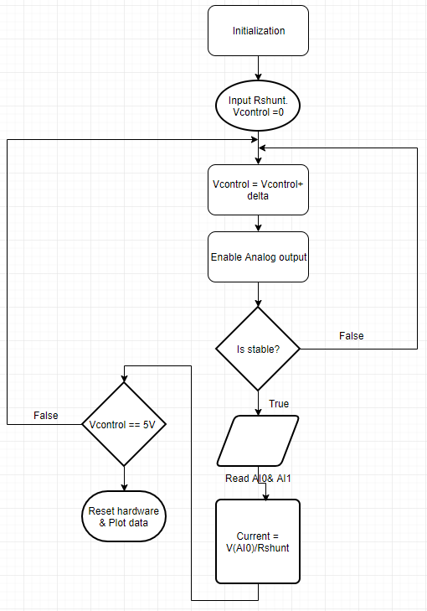
- Results:
This is some real result after done.
Circuit on breadboard
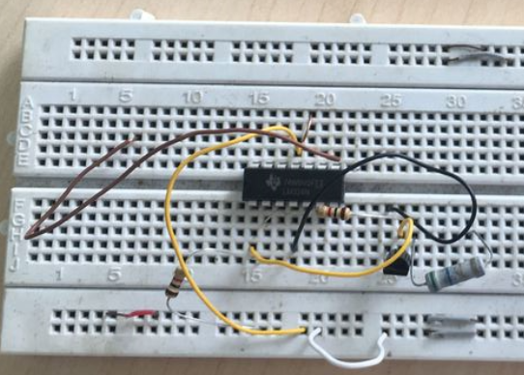

Plot I-V

